The Irish Embassy Bursary Programme
CALL FOR APPLICATIONS FOR SCHOLARSHIPS TO IRELAND IN 2020

Application deadline for scholarship: 29th February, 2020

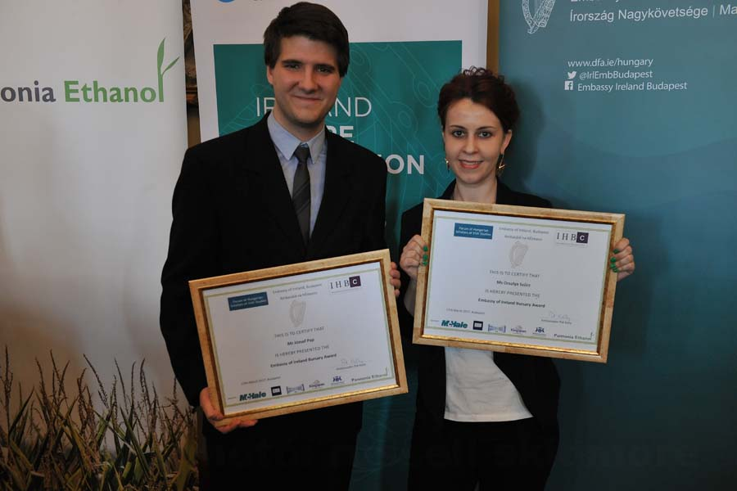

The Irish Embassy to Hungary is now accepting applications for its Irish Embassy Bursary Programme

The Irish Embassy Bursary Programme was established by the Embassy of Ireland in Hungary, the Irish Hungarian Business Circle (IHBC), and by the Forum of Scholars of Irish Studies in Budapest in November 2014. The annual Bursary programme was established with the purpose of supporting a limited number of Hungarian under-graduate, graduate and, or postgraduate students’ studying Irish topics in history, society, language, literature, culture, politics, music, visual arts, business and architecture in Ireland by means of contributing towards the costs associated with attending a summer school or conducting research in an Irish institute. In 2016/2017 business studies and architecture were added to the qualifying subjects.

Eligibility for the grant:
Hungarian undergraduate, graduate and post graduate students are eligible for the award to
- Attend a summer school in Ireland relating to the topic of the candidates research
- Visit an Irish Research Institute (e.g.: National Library of Ireland, TCD Library, NUI Galway, Irish Film Institute or other relevant institution) to carry out research directly related to their research topic.

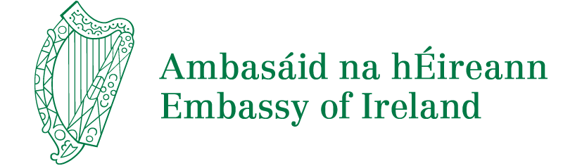

Criteria of application

Applicants must:

Have a high level proficiency in the English language and be competence in oral, writing, listening and reading skills

Have completed - or will have completed by the time of taking up the Bursary - their B.A. Degree at a Hungarian academic institution and have completed at least one but preferably more than one course, projects or pieces of work related to Irish topics as part of their B.A. Studies (e.g.:literature/language/culture/politics/history/society/music/visual arts/business/architecture)

or are writing/ have written a B.A thesis on an Irish related topic. Be currently registered for an M.A. Programme or a Ph.D. Programme at a Hungarian academic institution. Proof of acceptance for admission to postgraduate studies must be provided, Be researching – or preparing to research – an M.A. or Ph.D. thesis on a subject dealing partly or wholly with an Irish topic.

Application Process
The applicant must submit a set of documents, by the indicated deadline, to
Embassy of Ireland: budapestembassy@dfa.ie by both email and by post: Embassy of Ireland, 1054 Budapest, Szabadsag ter 7-9, Bank Centre, Granit Tower . VII floor. These shall consist of:
- Completed Official Form
- CV
- A letter of invitation from the institution where the applicant intends to pursue research or a letter from the director of the summer school the applicant intends to attend.
- Applicants intending to pursue research, must submit a research proposal signed by his/her supervisor from his/her home institution. Students aiming to attend a summer school must submit a letter of recommendation from an academic from his/her home institution.
- All applicants have to guarantee that she/he can cover the self finance part of the Irish summer course
- All applications should be submitted by email and by post and meet the given deadline. Application calls are published from 19th January 2020 till 19th February 2020.
- Application deadline for scholarship: 29th February, 2020.
- Any application submitted after 29th February, 2020 will be automatically rejected.
- Official results: 1st April 2020.

The Irish Embassy shall inform the successful candidate that he/she is granted the award in March 2018 and invite him/her to sign a Bursary Contract with the Irish Hungarian Business Circle. In the Bursary Contract, the contracting parties (IHBC and grantee) specify how the grant will be used, and what costs the grantee will have to meet by receipt. In the Bursary Contract, the grantee undertakes that with the acceptance of the award he/she shall conclude the research or attend the summer school that is specified in his/her work plan by the given deadline, and submit a brief report on its completion. Each bursary grantee shall arrange all travel practicalities with TENSI Travel Agency and the transfer of tuition fees and registration fees shall take place through IHBC. The grantee is obliged to abide by the terms of the Bursary Contract signed with IHBC. In case the grantee fails to complete the programme he/she is responsible for repaying the bursary amount.

Key Dates
Application deadline for scholarship: 29th February, 2020.
Programme starts: 1st May 2020
Programme ends: 20th December 2020.
For further Information, contact: Embassy of Ireland
Email: budapestembassy@dfa.ie and by post: Embassy of Ireland, 1054 Budapest, Szabadsag ter 7-9, Bank Centre, Granit Tower. VII floor.

