<https://neptun.sze.hu/en_GB/home>

Syllabus = TÁRGYTEMATIKA

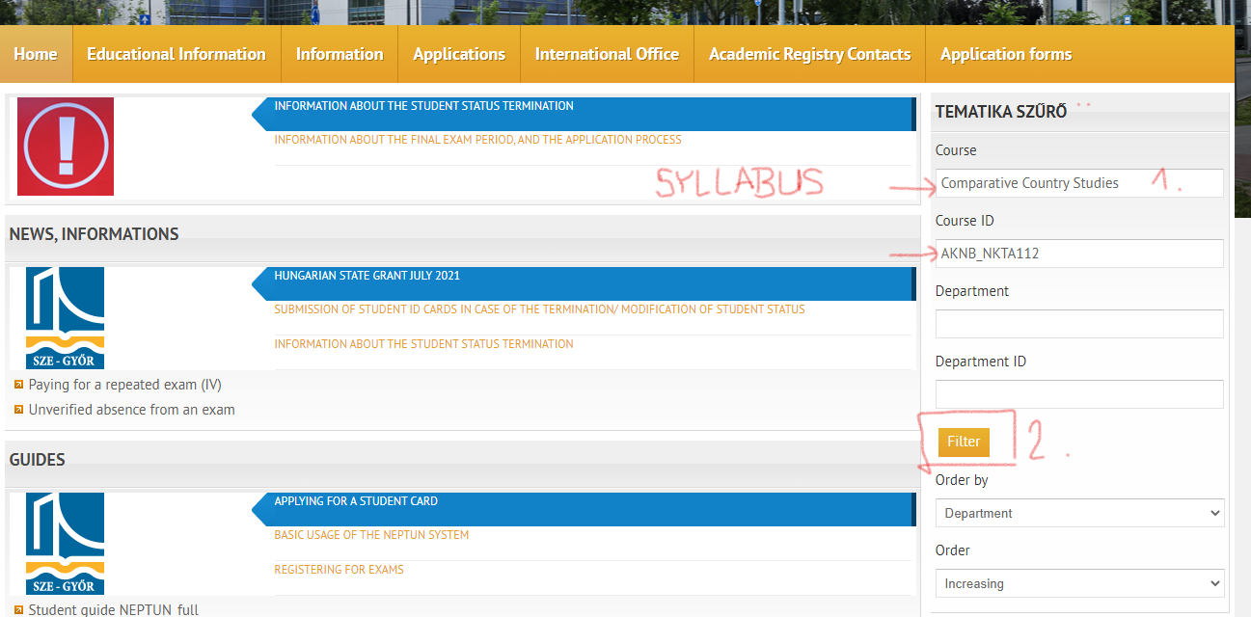

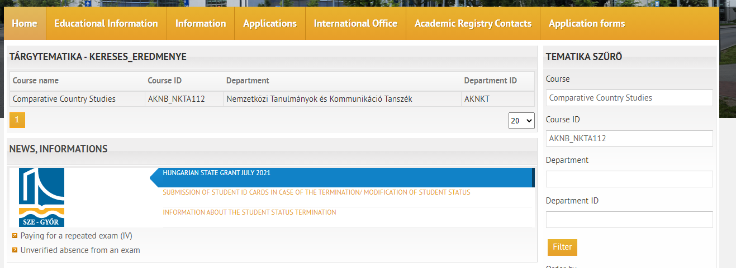

Please click on the course name, then you can download the syllabus.

